**SPATIAL DATABASES (CS – 615)  
DONKEY CART ASSIGNMENT**

**Name – Dhaval Harish Sharma  
Red ID – 824654344  
Oracle ID – st162**

**Question:  
Write insert queries into SDO_ GEOM and design the Donkey Cart image in MapViewer.**

**Solution:**I decided to be a little creative on this assignment. As a result, I included some more structures in the table other than the ones asked in the assignment. This includes mountains, sun, etc. The coordinates for the various objects are as follows:  
**[Rectangle]**  
Cart:  
(2.01, 6.92, 12.94, 9.03)  
(4, 6, 21.36, 6.92)

**[Line]**  
Birds:  
(18.88, 18.85, 19.53, 18.39)  
(19.53, 18.39, 20.09, 19.01)  
(17.71, 18.24, 18.13, 17.55)  
(18.13, 17.55, 18.5, 18.16)  
(19.21, 17.63, 19.67, 17.13)  
(19.67, 17.13, 20.14, 17.74)

Cart:  
(4.53, 9.03, 8, 12)  
(6, 12, 10, 9.03)

Snow:  
(4.53, 16.53, 6.72, 17.28)  
(11.26, 17.68, 15.49, 17.68)  
(21.39, 16.88, 23.55, 17.7)

Mouth:  
(31.25, 6.88, 33.01, 7.57)

Eye:  
(30.8, 8.53, 31.4, 8.87)

**[Circle]**  
Sun:  
(29.39, 17.44, 32.15, 18.32, 31.22, 16.21)

Wheel:  
(8.32, 5.98, 5.28, 3.94, 8.36, 1.95)

**[Polygon]**  
Donkey:  
(31.22, 10.02, 32.99, 8.34, 33.04, 6.47, 32, 6, 30.66, 7.57, 28.09, 5.55, 27.38, 4.4, 26.45, 3.14, 27.2, 2.03, 26.26, 2.03, 25.51, 3.22, 26.45, 4.4, 21.4, 4.43, 20.33, 3.02, 21.22, 2.03, 20.47, 2.03, 19.58, 3.02, 20.7, 4.43, 18.74, 4.44, 17.71, 5.97, 21.36, 5.97, 21.36, 6.92, 17.66, 6.92, 18.04, 7.46, 16.03, 6.92, 17.94, 8.26, 28.04, 8.3, 30, 10, 29.3, 11.47, 30.56, 10.63, 31.45, 11.63)

Donkey Seat:  
(21.96, 8.28, 21.4, 7.54, 25.66, 7.54, 26.17, 8.29)

Cart Box:  
(2.01, 9.03, 3.08, 10.98, 4.53, 10.98, 4.53, 9.03)  
(4.53, 9.03, 4.53, 10.98, 6, 12, 8, 12, 10.05, 10.67, 10, 9.03)

Tree:  
(16, 10, 16, 12, 15.23, 11.74, 14.67, 12.24, 14.86, 12.85, 14.67, 13.54, 16, 14, 16.73, 14.3, 16.87, 13.65, 17.94, 13.12, 17.94, 13.12, 17.66, 12.39, 16.73, 11.97, 16.73, 10.02)

Mountains:  
(2, 14, 6, 18, 10, 14)  
(10, 14, 8, 16, 14.11, 19.16, 19.11, 13.77)  
(19.11, 13.77, 22.8, 18.81, 26, 14)

Cart Box:  
(10.05, 10.67, 12.94, 9.03, 10, 9.03)

**The output for the SQL queries described below looks as follows in MapViewer:**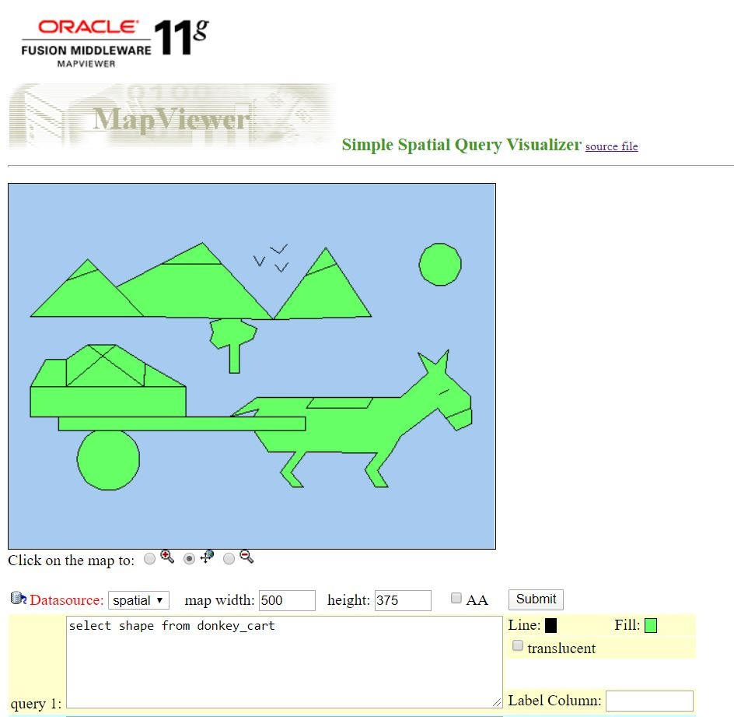

**The SQL queries for the above geometrical shapes are as follows:**  
DROP TABLE donkey_cart;

CREATE TABLE donkey_cart (

id NUMBER PRIMARY KEY,

name VARCHAR2(32),

shape MDSYS.SDO_GEOMETRY);

INSERT INTO donkey_cart VALUES(

1,

'Polygon',

MDSYS.SDO_GEOMETRY(

2003,

NULL,

NULL,

MDSYS.SDO_ELEM_INFO_ARRAY(1,1003,1),

MDSYS.SDO_ORDINATE_ARRAY(31.22, 10.02, 32.99, 8.34, 33.04, 6.47, 32, 6, 30.66, 7.57, 28.09, 5.55, 27.38, 4.4, 26.45, 3.14, 27.2, 2.03, 26.26, 2.03, 25.51, 3.22, 26.45, 4.4, 21.4, 4.43, 20.33, 3.02, 21.22, 2.03, 20.47, 2.03, 19.58, 3.02, 20.7, 4.43, 18.74, 4.44, 17.71, 5.97, 21.36, 5.97, 21.36, 6.92, 17.66, 6.92, 18.04, 7.46, 16.03, 6.92, 17.94, 8.26, 28.04, 8.3, 30, 10, 29.3, 11.47, 30.56, 10.63, 31.45, 11.63)

)

);

INSERT INTO donkey_cart VALUES(

2,

'Polygon',

MDSYS.SDO_GEOMETRY(

2003,

NULL,

NULL,

MDSYS.SDO_ELEM_INFO_ARRAY(1,1003,1),

MDSYS.SDO_ORDINATE_ARRAY(21.96, 8.28, 21.4, 7.54, 25.66, 7.54, 26.17, 8.29)

)

);

INSERT INTO donkey_cart VALUES(

3,

'Polygon',

MDSYS.SDO_GEOMETRY(

2003,

NULL,

NULL,

MDSYS.SDO_ELEM_INFO_ARRAY(1,1003,1),

MDSYS.SDO_ORDINATE_ARRAY(2.01, 9.03, 3.08, 10.98, 4.53, 10.98, 4.53, 9.03)

)

);

INSERT INTO donkey_cart VALUES(

4,

'Polygon',

MDSYS.SDO_GEOMETRY(

2003,

NULL,

NULL,

MDSYS.SDO_ELEM_INFO_ARRAY(1,1003,1),

MDSYS.SDO_ORDINATE_ARRAY(4.53, 9.03, 4.53, 10.98, 6, 12, 8, 12, 10.05, 10.67, 10, 9.03)

)

);

INSERT INTO donkey_cart VALUES(

5,

'Polygon',

MDSYS.SDO_GEOMETRY(

2003,

NULL,

NULL,

MDSYS.SDO_ELEM_INFO_ARRAY(1,1003,1),

MDSYS.SDO_ORDINATE_ARRAY(10.05, 10.67, 12.94, 9.03, 10, 9.03)

)

);

INSERT INTO donkey_cart VALUES(

6,

'Circle',

MDSYS.SDO_GEOMETRY(

2003,

NULL,

NULL,

MDSYS.SDO_ELEM_INFO_ARRAY(1,1003,4),

MDSYS.SDO_ORDINATE_ARRAY(29.39, 17.44, 32.15, 18.32, 31.22, 16.21)

)

);

INSERT INTO donkey_cart VALUES(

7,

'Circle',

MDSYS.SDO_GEOMETRY(

2003,

NULL,

NULL,

MDSYS.SDO_ELEM_INFO_ARRAY(1,1003,4),

MDSYS.SDO_ORDINATE_ARRAY(8.32, 5.98, 5.28, 3.94, 8.36, 1.95)

)

);

INSERT INTO donkey_cart VALUES(

8,

'Line',

MDSYS.SDO_GEOMETRY(

2,

NULL,

NULL,

MDSYS.SDO_ELEM_INFO_ARRAY(1,2,1),

MDSYS.SDO_ORDINATE_ARRAY(18.88, 18.85, 19.53, 18.39)

)

);

INSERT INTO donkey_cart VALUES(

9,

'Line',

MDSYS.SDO_GEOMETRY(

2,

NULL,

NULL,

MDSYS.SDO_ELEM_INFO_ARRAY(1,2,1),

MDSYS.SDO_ORDINATE_ARRAY(19.53, 18.39, 20.09, 19.01)

)

);

INSERT INTO donkey_cart VALUES(

10,

'Line',

MDSYS.SDO_GEOMETRY(

2,

NULL,

NULL,

MDSYS.SDO_ELEM_INFO_ARRAY(1,2,1),

MDSYS.SDO_ORDINATE_ARRAY(17.71, 18.24, 18.13, 17.55)

)

);

INSERT INTO donkey_cart VALUES(

11,

'Line',

MDSYS.SDO_GEOMETRY(

2,

NULL,

NULL,

MDSYS.SDO_ELEM_INFO_ARRAY(1,2,1),

MDSYS.SDO_ORDINATE_ARRAY(18.13, 17.55, 18.5, 18.16)

)

);

INSERT INTO donkey_cart VALUES(

12,

'Line',

MDSYS.SDO_GEOMETRY(

2,

NULL,

NULL,

MDSYS.SDO_ELEM_INFO_ARRAY(1,2,1),

MDSYS.SDO_ORDINATE_ARRAY(19.21, 17.63, 19.67, 17.13)

)

);

INSERT INTO donkey_cart VALUES(

13,

'Line',

MDSYS.SDO_GEOMETRY(

2,

NULL,

NULL,

MDSYS.SDO_ELEM_INFO_ARRAY(1,2,1),

MDSYS.SDO_ORDINATE_ARRAY(19.67, 17.13, 20.14, 17.74)

)

);

INSERT INTO donkey_cart VALUES(

14,

'Line',

MDSYS.SDO_GEOMETRY(

2,

NULL,

NULL,

MDSYS.SDO_ELEM_INFO_ARRAY(1,2,1),

MDSYS.SDO_ORDINATE_ARRAY(4.53, 9.03, 8, 12)

)

);

INSERT INTO donkey_cart VALUES(

15,

'Line',

MDSYS.SDO_GEOMETRY(

2,

NULL,

NULL,

MDSYS.SDO_ELEM_INFO_ARRAY(1,2,1),

MDSYS.SDO_ORDINATE_ARRAY(6, 12, 10, 9.03)

)

);

INSERT INTO donkey_cart VALUES(

16,

'Rectangle',

MDSYS.SDO_GEOMETRY(

2003,

NULL,

NULL,

MDSYS.SDO_ELEM_INFO_ARRAY(1,1003,3),

MDSYS.SDO_ORDINATE_ARRAY(2.01, 6.92, 12.94, 9.03)

)

);

INSERT INTO donkey_cart VALUES(

17,

'Rectangle',

MDSYS.SDO_GEOMETRY(

2003,

NULL,

NULL,

MDSYS.SDO_ELEM_INFO_ARRAY(1,1003,3),

MDSYS.SDO_ORDINATE_ARRAY(4, 6, 21.36, 6.92)

)

);

INSERT INTO donkey_cart VALUES(

18,

'Polygon',

MDSYS.SDO_GEOMETRY(

2003,

NULL,

NULL,

MDSYS.SDO_ELEM_INFO_ARRAY(1,1003,1),

MDSYS.SDO_ORDINATE_ARRAY(16, 10, 16, 12, 15.23, 11.74, 14.67, 12.24, 14.86, 12.85, 14.67, 13.54, 16, 14, 16.73, 14.3, 16.87, 13.65, 17.94, 13.12, 17.94, 13.12, 17.66, 12.39, 16.73, 11.97, 16.73, 10.02)

)

);

INSERT INTO donkey_cart VALUES(

19,

'Polygon',

MDSYS.SDO_GEOMETRY(

2003,

NULL,

NULL,

MDSYS.SDO_ELEM_INFO_ARRAY(1,1003,1),

MDSYS.SDO_ORDINATE_ARRAY(2, 14, 6, 18, 10, 14)

)

);

INSERT INTO donkey_cart VALUES(

20,

'Polygon',

MDSYS.SDO_GEOMETRY(

2003,

NULL,

NULL,

MDSYS.SDO_ELEM_INFO_ARRAY(1,1003,1),

MDSYS.SDO_ORDINATE_ARRAY(10, 14, 8, 16, 14.11, 19.16, 19.11, 13.77)

)

);

INSERT INTO donkey_cart VALUES(

21,

'Polygon',

MDSYS.SDO_GEOMETRY(

2003,

NULL,

NULL,

MDSYS.SDO_ELEM_INFO_ARRAY(1,1003,1),

MDSYS.SDO_ORDINATE_ARRAY(19.11, 13.77, 22.8, 18.81, 26, 14)

)

);

INSERT INTO donkey_cart VALUES(

22,

'Line',

MDSYS.SDO_GEOMETRY(

2,

NULL,

NULL,

MDSYS.SDO_ELEM_INFO_ARRAY(1,2,1),

MDSYS.SDO_ORDINATE_ARRAY(4.53, 16.53, 6.72, 17.28)

)

);

INSERT INTO donkey_cart VALUES(

23,

'Line',

MDSYS.SDO_GEOMETRY(

2,

NULL,

NULL,

MDSYS.SDO_ELEM_INFO_ARRAY(1,2,1),

MDSYS.SDO_ORDINATE_ARRAY(11.26, 17.68, 15.49, 17.68)

)

);

INSERT INTO donkey_cart VALUES(

24,

'Line',

MDSYS.SDO_GEOMETRY(

2,

NULL,

NULL,

MDSYS.SDO_ELEM_INFO_ARRAY(1,2,1),

MDSYS.SDO_ORDINATE_ARRAY(21.39, 16.88, 23.55, 17.7)

)

);

INSERT INTO donkey_cart VALUES(

25,

'Line',

MDSYS.SDO_GEOMETRY(

2,

NULL,

NULL,

MDSYS.SDO_ELEM_INFO_ARRAY(1,2,1),

MDSYS.SDO_ORDINATE_ARRAY(30.8, 8.53, 31.4, 8.87)

)

);

INSERT INTO donkey_cart VALUES(

26,

'Line',

MDSYS.SDO_GEOMETRY(

2,

NULL,

NULL,

MDSYS.SDO_ELEM_INFO_ARRAY(1,2,1),

MDSYS.SDO_ORDINATE_ARRAY(31.25, 6.88, 33.01, 7.57)

)

);

INSERT INTO USER_SDO_GEOM_METADATA

VALUES (

'donkey_cart',

'shape',

MDSYS.SDO_DIM_ARRAY(

MDSYS.SDO_DIM_ELEMENT('X', 0, 20, 0.005),

MDSYS.SDO_DIM_ELEMENT('Y', 0, 20, 0.005)

),

NULL

);

CREATE INDEX donkey_cart_idx

ON donkey_cart(shape)

INDEXTYPE IS MDSYS.SPATIAL_INDEX;